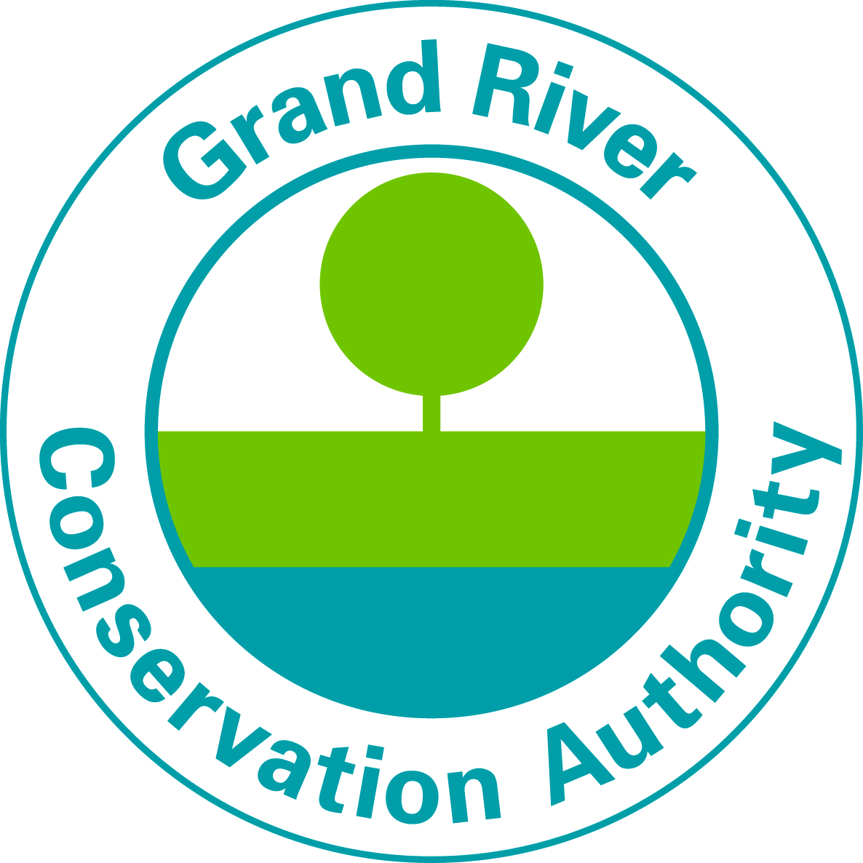

Summer Student Job Posting

Maintenance - Conservation Areas
Each summer, the Grand River Conservation Areas welcomes visitors to enjoy camping, swimming, boating, tubing, fishing and hiking.
We are looking for students that want to be part of our team connecting people to the environment through outdoor experiences. This is a great opportunity to meet new people, work outside in an inspiring setting and gain valuable work experience.

What you will be doing:
You will work together as a team keeping our lanscapes beautiful and our facilities clean. You will also engage with our visitors to ensure they have an enjoyable stay.

Advantages:
- Work outside in a beautiful setting.
- A memorable summer working with your peers.
- Consistent full time hours.
- A schedule for the full season.
- Eligibility to enrol in our pension plan (OMERS).

Requirements:
- Currently enrolled as a full time student.
- Interest in working independently and in a team environment.
- Availability to work weekends and evenings.
- Valid Ontario G or G2 Driver’s licence.

Work Period: May to Labour Day 2023 (potential of shifts to October)
Pay Rate: $15.50 per hour
Shift: Weekends, Day and Evening Shifts, Statutory Holidays
Up to 40 hours per week (Part-time hours also available)
Conservation Areas Locations:
Byng Island
All successful applicants must possess their own Green Patch CSA approved safety boots, be able to work outdoors in all weather conditions and be available to work the duration of the season.
We offer comprehensive health and safety training .
To Apply:
Please send your resume and cover letter (referencing location and Gate Attendant) by email to careers@grandriver.ca (Please send your resume and cover letter as an MS Word document or PDF) or apply on-line Conservation Area student jobs - Grand River Conservation Authority
Please visit our website to view all student positions Student Summer Jobs 2023
Deadline for Applications is April 26, 2023.
Interviews dates will be March to April 2023
If selected for an interview, you will be contacted by email and/or phone. Please ensure the contact information provided on your resume is up to date and that you check your email and voicemail regularly.

Applications submitted after April 26th 2023, will only be reviewed on an as needed basis.
We thank you for your interest, however only candidates under consideration will be contacted.

GRCA is an equal opportunity employer. We are committed to inclusive, barrier-free recruitment and selection processes and work environments. If you require any accessibility accommodations at any point during the application and hiring process, please contact us. Any information received relating to accommodation will be addressed confidentially
Pursuant to section 29(2) of the Municipal Freedom of Information and Protection of Individual Privacy Act R.S.O. 1990, C. M.56 the personal information contained on this form is collected under the legal authority of the Conservation Authorities Act, R.S.O. 1990, chapter C.27 and is used for recruitment purposes. Questions about the collection of personal information should be directed to the Manager of Human Resources, Grand River Conservation Authority, PO Box 729, 400 Clyde Road, Cambridge, Ontario N1R 5W6. 519-621-2761.

