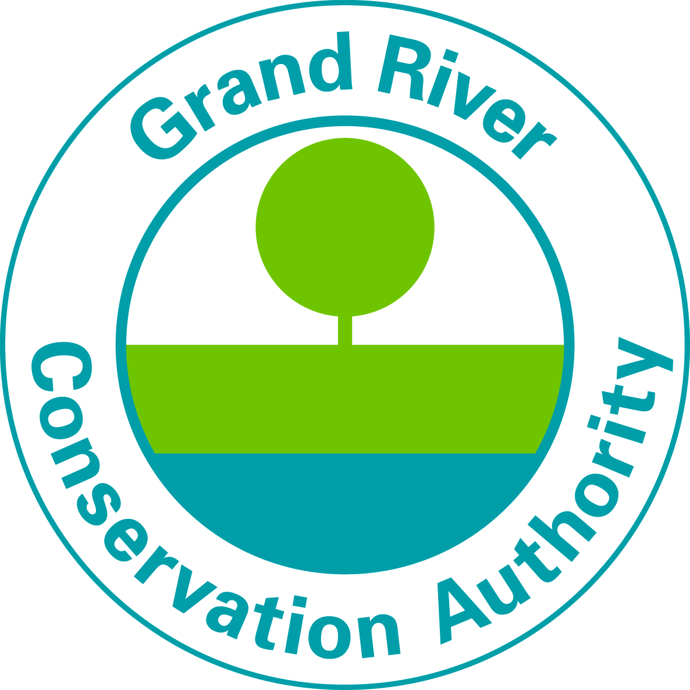

Summer Student Job Posting
Full Time Position

Head Lifeguard –Byng Conservation Area
Each summer, the Grand River Conservation Areas welcomes visitors to enjoy camping, swimming, boating, tubing, fishing and hiking.

We are looking for an energetic and responsible student that wants to be part of our team connecting people to the environment through outdoor experiences. This is a great opportunity to meet new people, work outside in an inspiring setting and gain valuable work experience.

What you will be doing:
The Head Lifeguard position reports to the park superintendent and is responsible for leading a lifeguard team and providing an enjoyable, clean and safe outdoor pool facility for our visitors.
- Ensure that all lifeguarding and safety procedures are adhered to.
- Support the supervision of up to 16 Lifeguard staff.
- Help support the Superintendent with scheduling, training and assessing staff performance.
- Maintain a safe, clean pool, pool deck, surrounding area, washrooms and changerooms.
- Have proficient knowledge of emergency procedures and use of equipment.
- Enforce pool and park regulations.
- Responsible for reporting all incidents/accidents and concerns to the Superintendent or designate.
- Complete the daily pool log sheet, including pre-opening checks, pool maintenance and scheduled water checks.

Advantages:
- Gaining leadership experience.
- Meet new people and create life long friendships.
- Work outside in a beautiful setting.
- Continuous training and support.
- Eligibility to enrol in our pension plan (OMERS).

Requirements:
- Currently enrolled as a full time student.
- Current National Lifeguard Certification.
- Must possess Valid First Aid and CPR certification.
- Minimum 3 years experience in lifeguarding.
- Must possess a valid Ontario Driver’s License (G2 or G).
- Ability to demonstrate leadership skills and problem solving skills.
- Excellent communication and interpersonal skills.
- Familiar with the Grand River Conservation Authority and park policies.
- Ability to take initiative and lead within a team environment.
- The drive and passion to work weekends, night shifts and holidays with minimum supervision.

Work Period: June to Labour Day 2023
Pay Rate: $22.00 per hour
Shift: Weekends, Day and Evening Shifts, Statutory Holidays
All successful applicants must be able to work outdoors in all weather conditions and be available to work assigned shifts for the duration of the season.
We offer comprehensive health and safety training
To Apply:
Please send your resume and cover letter (referencing location and lifeguard) by email to careers@grandriver.ca (Please send your resume and cover letter as an MS Word document or PDF)or apply on-line at Conservation Area student jobs - Grand River Conservation Authority
Please visit our website to view all student positions Student Summer Jobs 2023
Deadline for Applications is April 26, 2023.
Interviews dates will be March to April 2023
If selected for an interview, you will be contacted by email and/or phone. Please ensure the contact information provided on your resume is up to date and that you check your email and voicemail regularly.
Applications submitted after April 26th, 2023, will only be reviewed on an as needed basis.
We thank you for your interest, however only candidates under consideration will be contacted.

GRCA is an equal opportunity employer. We are committed to inclusive, barrier-free recruitment and selection processes and work environments. If you require any accessibility accommodations at any point during the application and hiring process, please contact us. Any information received relating to accommodation will be addressed confidentially
Pursuant to section 29(2) of the Municipal Freedom of Information and Protection of Individual Privacy Act R.S.O. 1990, C. M.56 the personal information contained on this form is collected under the legal authority of the Conservation Authorities Act, R.S.O. 1990, chapter C.27 and is used for recruitment purposes. Questions about the collection of personal information should be directed to the Manager of Human Resources, Grand River Conservation Authority, PO Box 729, 400 Clyde Road, Cambridge, Ontario N1R 5W6. 519-621-2761.

