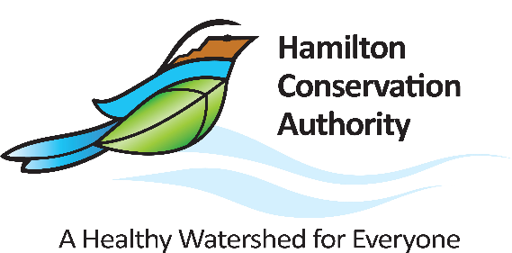

**INTERNAL / EXTERNAL JOB POSTING**

**The Hamilton Conservation Authority**

**is hiring a**

**Full Time Monitoring Technologist**

Reporting to the Manager Water Resources Engineering, the Monitoring Technologist is responsible for data collection, data processing, data analysis, identification of potential water quality concerns, and draft reporting related to the Hamilton Harbour Remedial Action Plan (HHRAP) water quality sampling program. Another key responsibility is to assist the Manager Water Resources Engineering with Flood Forecasting & Warning and Low Water Response programs, through data collection, data processing and initial assessments of flooding potential. Furthermore, this position is relied upon for collecting, maintaining and managing water resources data as part of the Hamilton Conservation Authority water quality sampling programs, Flood Forecasting and Warning, Low Water Response, hydrometric network and data, and other environmental sampling programs.

**Major Responsibilities and Duties**:

**Hamilton Harbour Remedial Action Plan (HHRAP) Surface Water Quality Monitoring**

* + Responsible for planning and implementing the routine collection of water samples
  + Process and analyze sample results
  + Responsible for writing reports for the HHRAP water quality sampling program
  + Analysis of water quality findings for the sampling year and how it compares to target objectives and long-term trends.
  + Act as the key point of contact for HHRAP members
  + Provide technical advice to the Manager Water Resources Engineering regarding potential program enhancements

**City of Hamilton specific programs supported by the Water Monitoring Program**

* Responsible for managing and implementing City of Hamilton specific programs supported by the Water Monitoring Program

**Forecasting & Warning program AND Low Water Response program**

* + Responsible for the collection and inputting of monthly precipitation totals and daily flows relating to low water response, as well as calculating % of Long Term Averages using spreadsheet-based tools
  + Responsible for the collection and inputting of weather forecast and recent daily precipitation totals, current watercourse conditions, Lake Ontario water level and wave forecasts, as well as calculating snowmelt forecasts using two spreadsheet-based forecasting tools.
  + Develop initial assessments of the potential of watercourse and shoreline flooding for use by the Manager Water Resources Engineering.

**Gauge maintenance and snow surveys**

* Undertake the maintenance of 10 precipitation gauges, 2 reservoir level gauges, and 1 streamflow gauge, which form vital input to the assessment of potential flooding.

**Provincial Water Quality Monitoring Network (PWQMN)**

* Responsible for collection of water quality samples and field parameters, as well as for the analysis and internal reporting of annual sampling results and comparison to objectives and long term trends.

**Other duties as assigned**

**Minimum Qualifications:**

* A graduate of a university or college program specializing in resources management or related environmental sciences
* 2 years of work experience with surface water quality sampling, and the associated data management and analysis
* 1 years of work experience with precipitation and streamflow gauges, and the associated data management and analysis
* 1 years of work experience with groundwater well inspections and groundwater water sampling

**Knowledge, Skills and Abilities:**

* Moderate understanding of principles and approaches related to water quality sampling, flood forecasting, hydrology, fluvial geomorphology, natural resources management, and environmental impact assessment, and knowledge of watershed management and land use planning processes
* Strong problem-solving and analytical skills
* Ability to work outdoors to conduct field investigations in variable terrain and weather conditions
* Positive team player capable of self-directed, independent work
* Possess a valid Ontario driver's license
* Proficient with the use of Microsoft Office software suite including database management (Microsoft Word, Excel, PowerPoint, Access), and experience working with Geographic Information Systems (GIS)

**Working Conditions:**

This position will be based at the HCA’s main office at 838 Mineral Springs Road, Ancaster, Ontario. However, some time will be spent out of office attending meetings and conducting site visits and inspections on properties throughout the watershed. A majority of work time is spent outdoors in all types of weather conditions. Working hours will total 37.5 per week, Monday through Friday inclusive with the additional requirement of evening meetings and occasional work on weekends.

**Rate of Pay and Benefits:**

This is a Full-Time position. The rate of pay is $62,086 annually. HCA offers a comprehensive benefits package including health, dental, vision care, after the 3-month probation period and a defined contribution pension plan after 1 years’ service.

**Application Process**

Interested applicants should email their resume and covering letter by **4:00 pm** on **Friday, October 6, 2023 to:**

**Hamilton Conservation Authority**

**Attention: Director of Human Resources and Wellness**

**Email:** [**jobs@conservationhamilton.ca**](mailto:jobs@conservationhamilton.ca)

**(Quote “Monitoring Technologist” in subject line and send in MS Word or PDF format)**

Although we appreciate the interest of all applicants, only those selected for an interview will be contacted.

Accessibility accommodations are available for all parts of the recruitment process; applicants are asked to inform Human Resources for any disability required accommodations in advance