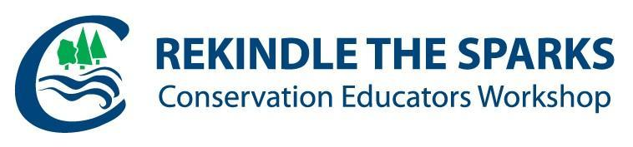

**November 20-22, 2019 | Mono Cliffs Outdoor Education Centre**

**2019 Awards Nomination Form**

**Deadline: Saturday, October 19, 2019**

**INNOVATION AWARD**

**Nomination:** Group - Conservation Authority

**Criteria:**

* Conservation Authority showing leadership in innovation within a Conservation Education framework
* Nominate CA’s innovative education projects, partnerships and/or programs
* Outside nomination is not required
* Nominations require a brief description and photograph of innovation
* Winners to be selected by a participant vote at the 2019 Rekindle the Sparks Conservation Education Workshop

**OUTSTANDING ACHIEVEMENT AWARD**

**Nomination:**Individual

**Criteria:**

* Individual employed by a Conservation Authority with a dedicated career conducting formal or non‐formal Conservation Education Programs
* Individual have made a significant and long-standing difference in Conservation Education
* Fostering community awareness and stewardship of land, water, and/or air
* Creating/innovating new education programs and/or projects

* Building/maintaining impactful community education partnerships
* External nomination required
* Winner selected by the Rekindle Awards Committee

**_____________________________________________________________________________**

**AWARDS CEREMONY**

**Thursday,** **November 21, 2019 | Rekindle the Sparks Conservation Education Workshop**

**For more information about the 2019 Rekindle Awards or to join the Rekindle Awards Committee,**

**please contact Melissa Levi** [**mlevi@scrca.on.ca**](mailto:mlevi@scrca.on.ca) **or Shintu Cherian** [**shintu.cherian@cvc.ca**](mailto:shintu.cherian@cvc.ca)**.**



**November 20-22, 2019 | Mono Cliffs Outdoor Education Centre**

**2019 INNOVATION AWARD NOMINATION FORM**

**Nominee Conservation Authority:**

**Conservation Authority Innovation:**

**Conservation Authority Contact Person:**

**Conservation Authority Phone/Email:**

Nominator Name & CA:

Nominator Phone/Email:

*\*****required only if external nomination***

**Photo Submission:**

***Please submit one quality photo/diagram that best reflects the success of your innovation***

**Brief description of Innovation:**

***Maximum 200 words***



**November 20-22, 2019 @ Mono Cliffs Outdoor Education Centre**

**2019 OUTSTANDING ACHIEVEMENT AWARD NOMINATION FORM**

**Nominee Name:**

**Nominee Conservation Authority:**

**Nominee Position:**

**Years of Dedication:**

**Nominee Phone/Email:**

Nominator Name:

Nominator Conservation Authority:

Nominator Position:

Nominator Phone/Email:

**Support Letter:   
*Provide a brief outline of how nominee meets the criteria (maximum 200 words)***

**Scoring Criteria:**

* Years of service
* Achievements in building educational community partnerships
* Achievements in completing educational projects
* Contribution to education within watershed communities
* Social impact within watershed communities
* Number of communities benefited or evidence of growth
* Please include any additional information to support your submission. (e.g.: photographs, partner/student testimony, media coverage, etc.).  Additional support is helpful, but not mandatory.